Organisation Information Requirements
Template

Contents
1 Introduction 1
2 Goals and policies 2
2.1 Relevant policies and external influences 2
3 Information requirements and activities 3
4 Information management structure and responsibilities 4
4.1 Organisational structure 4
4.1.1 Internal organisation groups 4
4.1.2 External organisation groups 4
5 Governance 5

Figures
Figure 1.1: Hierarchy of information requirements, source: ISO 19650–1:2018 1
Tables
Table 2.1: Goals, strategic policies and influences 2
Table 3.1: Information requirements schedule 3

Introduction
This document provides the organisational information requirements (OIR), as defined within the ISO 19650 series, as part of the information management using building information modelling (BIM) processes adopted by {organisation name}.
{Organisation name} has adopted the use of information management using building information modelling (BIM) to support the organisation’s asset information management strategy, throughout the life cycle of any given project or asset, whether proposed or existing. This will help {organisation name} and potential partnering organisations to generate cost savings across all project stages, and during the through-life management of assets and associated portfolios.
Figure 1 (below) illustrates the hierarchy of the scope of the organisational information requirements (OIR) and how it influences the subsequent information requirements and project information deliverables of the delivery phase of an asset, as stated in ISO 19650–1:2018.
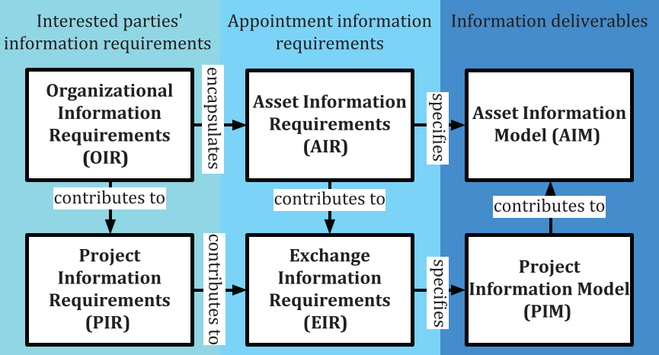
Figure 1.1: Hierarchy of information requirements, source: ISO 19650–1:2018

Goals and policies
< Communicate the high-level information management goals, objectives and existing policies that will be obtained through the adoption of ISO 19650 series principles through day-to-day activities.>

Relevant policies and external influences
<Table 2.1 (Goals, strategic policies and influences) outlines the strategic policies and external influences, such as regulations, that determine the requirements of capturing and using information related to organisational objectives.>
Table 2.1: Goals, strategic policies and influences
Goals | Objective | Policy or influencer
 |  | Internal | Regulatory
<Insert goals> | <Insert objective> | <Insert policy> | <Insert regulatory standards>

Information requirements and activities
<Table 3.1 (Information requirements schedule) outlines the high-level activities, and relevant information requirements, of the organisation’s information management objectives, which could include any new initiatives that are to be deployed.>
Table 3.1: Information requirements schedule
Goals | Objectives | Policy or influencer  (if applicable) | Information requirements | Information containers | Group/  department | Project stage/information delivery milestone
<Insert objective> | <Insert objective> | <Insert policy or external influence> | <Insert information requirements> | <Insert information containers> | <Insert group/  department> | <Insert project stage/  Information delivery milestone>

Information management structure and responsibilities
< Provide a high-level understanding of the existing or proposed organisational structure. This could include both internal and external stakeholders.>

Organisational structure
<Outline the organisational structure for information management processes, which should identify internal departments, associated processes/policies and any required interaction with external stakeholders.>

Internal organisation groups
<Outline and describe the relevant internal departments, groups and organisations that appear within the organisational structure.>

External organisation groups
<Outline and describe the relevant external departments, groups and organisations that appear within the organisational structure.>

Governance
<Explain the change management processes of the organisation information requirements (OIR) and processes to ensure their continual improvement.>

